5.26: The coefficient of kinetic friction is the ratio 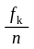, and the normal force has magnitude 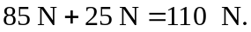 The friction force, from 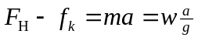 is
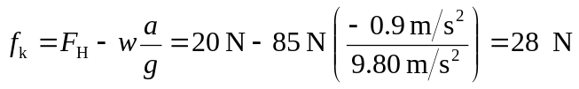
(note that the acceleration is negative), and so 